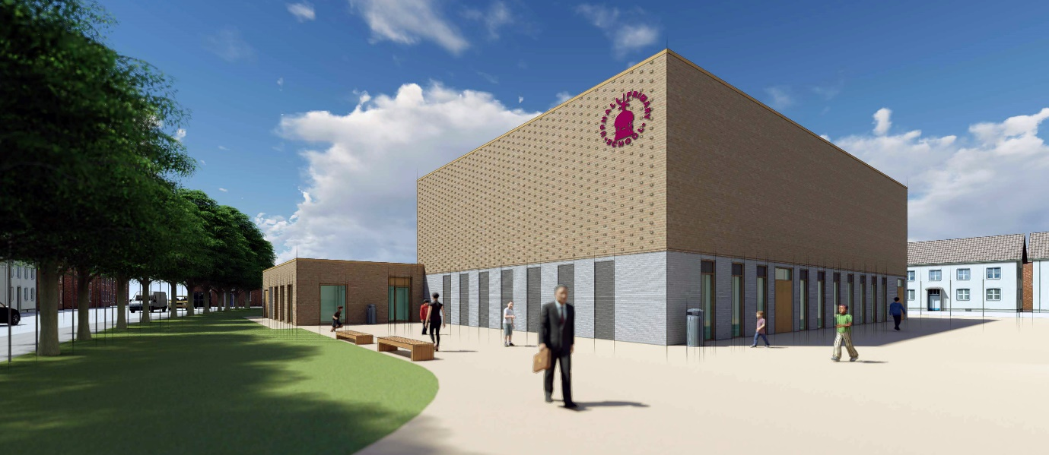
Dear Parent Carers.
We are very excited to share with you all that the long awaited new dining hall is coming to the final stage of the build. The building company John Rowan and Partners have informed us that it will be ready for us to use from the 21st November 2020.
From Wednesday 22nd October our old kitchen will be decommissioned. This means it will be closing down and all of the cooking equipment removed. We will no longer be able to prepare any food on the school site.
ISS Caterworld and the school have now put in place plans for how the children will receive their school lunches from the period 22nd October to Friday 20th November.
This will entail the continuing of cold ‘picnic lunches’ that will be prepared at another Redbridge Primary School, and then transported fresh every morning to Uphall Primary School.
In school the children will use the Healthy Minds School Meal ordering system in the classrooms, which they are all fully conversant with, and will each day choose their picnic sandwich filling, as well as a choice of fruit or dessert. The children will do this with the help of the teaching staff by 9.30am every morning. It is very important that every child who wishes to eat a school lunch order via this system.
For those children who have appointments or who will be arriving in school late (After 9.30am), it will mean that parents will have to provide them with a packed lunch from home on these days, as we will not have the facility to process late food orders or prepare any food on site.
I would like to thank you all for your patience during this time, and that we are very much looking forward to our new state of the art dining hall and the return of good quality hot food ready for the children for the winter months ahead.
If you have any questions, please do not hesitate to speak to your child’s classteacher or the Office Staff who will be happy to help in anyway.

Warm regards
The Uphall Family

